|  |
| --- |
| HANGAIA  TE URUPOUNAMU MŌ TĀTOU  **HAUTANGA** Taumata 1 (Tau 1) Copy Masters ODD YEARS |

**©** Developing Mathematical Inquiry Communities team, Institute of Education, Massey University

**Rapanga 1**

Kei te tohatoha koe i tētahi hanuwiti me tō hoa. Whakaatuhia tō hauruatanga ki tō hoa.

**Ngohe 1**

Whirihia tētahi ipu, whakakī mā te wai. Riringihia hawhe o te wai. He aha te wai e toe ana?

Kowhirihia tētahi atu ipu rerekē me te riringi hawhe anō. He aha tō kitenga?

Tāngia he pikitia hei whakaatu ou mahi. Tohu ate hawhe ki ia ipu.

**Rapanga 2**

Kei te hanga kāri motuhake kōrua ko tō tuahine, engari kōtahi te pepa. Me hawhe te pepa. He aha ngā momo hauruatanga rerekē? Me whakamārama ngā momo hauruatanga.

**Ngohe 2**

Whirihia tētahi ipu, whakakī mā te wai. Riringihia tētahi hautoru o te wai. He aha te wai e toe ana?

Kowhirihia tētahi atu ipu rerekē me te riringi hautoru anō. He aha tō kitenga?

Tāngia he pikitia hei whakaatu ou mahi. Tohua te hautoru ki ia ipu.

**Rapanga 3**

I karanga tētahi Māmā ki tana tamaiti “ka taea kōrua ko tō kaihana ki te toha tētahi patara wai ārani.” “Me inu orite kōrua.”

Pehea te nui ō tō inu? Pehea te nui ō te inu o tō kaihana?

**Ngohe 3**

Whirihia tētahi ipu, whakakī mā te wai. Riringihia tētahi hautoru o te wai ki te ipu tuarua. He aha te wai e toe ana i te ipu tuatahi? He aha te wai i te ipu tuarua? He aha tō kitenga?

Tāngia he pikitia hei whakaatu ou mahi me te tohua tētahi hautoru ki te ipu tuatahi me te 2 hautoru ki te ipu tuarua.

**Rapanga 4**

Tapahi ngā taare pepa kia rua, ā, me takaihia te pepa kia orite ngā wāhanga e rua. Ka taea e koe te whakamārama e hia ngā takainga kia hanga te taare? I tutuki ngā tapanga? Me whakarite kia whakamārama. Pehea e toru ngā tare? Ka taea te takaihia te pepa kia toru orite ngā wahanga? Me whakarite kia whakamārama?

**Ngohe 4**

Whakamahia he parāoa pokepoke kia rua ngā āhua e orite ana.

Hauruatia te wāhanga tuatahi. E hia ngā wāhanga?

Tāngia to pāraoa pokepoke me te whakaatu ngā wāhanga.

Whakamahia he parāoa pokepoke kia whā ngā āhua e orite ana.

Hauwhatia te wāhanga tuatahi. E hia ngā wāhanga?

Tāngia to pāraoa pokepoke me te whakaatu ngā wāhanga.

**Rapanga 5**

Whakamahia te rauemi hautanga kia hanga te kōtahi ki ngā taputapu hautanga rerekē. Tuhia me te tā to whakaturanga.   
Me whakamārama me te taunakihia ngā take ka hanga ngā wāhanga ki te kōtahi.

**Ngohe 5**

Whakamahia te rauemi hautau kia whakaatu ngā momo huinga rerekē ki te kōtahi.

Tāngia ou momo hei nama, hei kupu hoki e whakaatu ana te kōtahi.

**Rapanga 6**

Whakamahia te rauemi hautau kia hanga te kōtahi iti iho ki ngā taputapu hautanga rerekē. Tuhia me te tā to whakaaturanga. Me whakamārama me te taunakihia ngā take ka hanga ngā wāhanga ki te kōtahi iti iho.

Whakamahia te rauemi hautau kia hanga he mea nui ake i te kōtahi ki ngā taputapu hautanga rerekē. Tuhia me te tā to whakaaturanga. Me whakamārama me te taunakihia ngā take ka hanga ngā wāhanga ki te kōtahi nui ake.

**Ngohe 6**

He tika, he hē rānei ēnei rerenga tau?

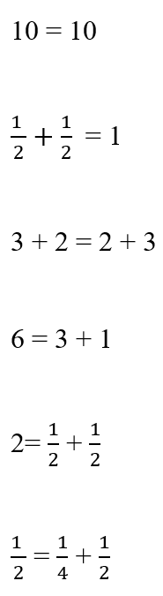

**Rapanga 7**

I tunu kēkē panana te kuia o Jayden rāua ko Martha. Ka tohua te kuia ki a rāua kia kai e toru ngā wahanga engari kia orite ngā wāhanga. E hia ngā wāhanga kēke panana ka kai rāua?

**Ngohe 7**

Whakamahia te rauemi hautau kia hanga:

Iti iho o te kōtahi

Iti iho o te hawhe

Kia orite ki te hawhe

Nui ake i te hawhe engari iti iho i te kōtahi.

Tāngia ou tauira hei kauwhata, hei kupu, hei wharite, hei nama ( hautanga) hoki

**Rapanga 8**

I tunu panikeke tetahi Māmā me tana tamāhine. I kai te Māmā i tētahi panikeke, ā, i toha tana tamāhine e 5 ngā panikeke me āna tuahine e toru. E hia ngā panikeke ka kai tana tamāhine me āna tuahine? Mēnā ka toha tētahi panikeke me tana tūngane, e hia ngā panikeke ka kai rātou?

**Ngohe 8**

I tunu pārāoa tētahi Pāpā. Pehea te nui o tau pāraoa mēnā ka toha:

Kōtahi he kotinga ki ngā tangata e rua.

E rua ngā kotinga ki ngā tangata e rua.

Kōtahi he kotinga ki ngā tangata e whā.

E rua ngā kotinga ki ngā tangata e wha.

Kōtahi he kotinga ki ngā tangata e toru.

E rua ngā kotinga ki ngā tangata e toru.

Kōtahi he kotinga ki ngā tangata e waru.

E rua ngā kotinga ki ngā tangata e waru.

Tā me te tuhi ngā whakamārama.

**Rapanga 9**

I tākaaro tahi a Ayla rāua ko Zack i tētahi kēmu motoka.

Tuatahi, i tā tētahi raina timatanga me tētahi raina whakamutunga ,ā , i pana rāua i ā rāua motoka kia tutuki ki te raina whakamutunga.

I tae hawhe te motoka a Ayla, ā, i tae hauwha te motoka a Zack. Kei a wai te motoka i tae tata ki te raina whakamutunga? Taunakihia tō whakamārama mā te tā pikitia o ngā raina.

Tuarua, i tae hauwha te motoka a Ayla, ā, i tae e rua hautoru te motoka a Zack. Kei a wai te motoka i tae tata ki te raina whakamutunga? Taunakihia tō whakamārama mā te tā pikitia o ngā raina.

Tuatoru. i tae e wha ngā hauwhā te motoka a Ayla, ā, i tae e rua haurua te motoka a Zack. Kei a wai te motoka i tae tata ki te raina whakamutunga? Taunakihia tō whakamārama mā te tā pikitia o ngā raina.

**Ngohe 9**

Ko tehea te waka i tae tata ki te raina whakamutunga? He aha te hautau o ia waka?

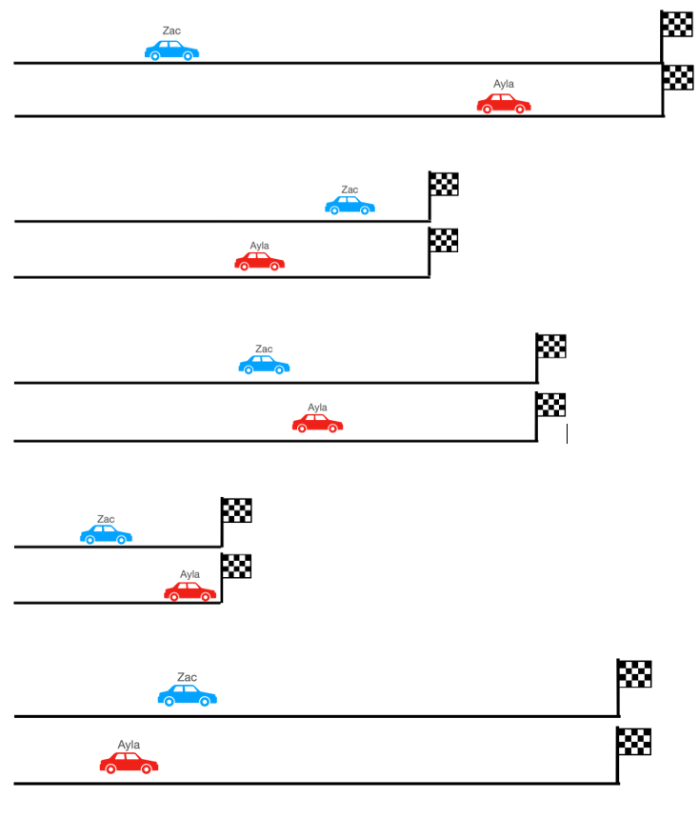

**Rapanga 10**

Kei a wai te mea nui ake? Kei a wai te mea iti iho?

Kei a Alefosio he hawhe pereti o te ika mata, kei a Kahi he hautoru o te pereti ika mata.

Kei a wai te mea nui ake? Kei a wai te mea iti iho?

Me whakamārama ou kitenga mā te pikitia.

Kei a wai te mea nui ake? Kei a wai te mea iti iho?

Kei a Alefosio he pereti hauwha o te ika mata, kei a Kahi e rua hautoru o te pereti ika mata.

Kei a wai te mea nui ake? Kei a wai te mea iti iho?

Me whakamārama ou kitenga mā te pikitia.

Kei a wai te mea nui ake? Kei a wai te mea iti iho?

Kei a Alefosio he pereti toru hauwha o te ika mata, kei a Kahi he hautoru o te pereti ika mata.

Kei a wai te mea nui ake? Kei a wai te mea iti iho?

Me whakamārama ou kitenga mā te pikitia.

**Ngohe 10**

Titiro ki ēnei hautanga i raro iho nei,ā, tohua he tauira o ia hautanga.

Nā, tā ngā tohu> ( nui ake), < (iti iho), = kia tika ngā whārite.

