| HANGAIA  TE URUPOUNAMU MŌ TĀTOU  **HAUTANGA** Taumata 2 (Tau 3) Copy Masters ODD YEARS |
| --- |

**©** Developing Mathematical Inquiry Communities team, Institute of Education, Massey University

**Rapanga 1**

Whakamahia te rauemi hautanga kia hanga te kōtahi ki ngā taputapu hautanga rerekē. Tuhia me te tā to whakaturanga. Me whakamārama me te taunakihia ngā take ka hanga ngā wāhanga ki te kōtahi.

Whakamahia te rauemi hautanga kia hanga tata ki te kōtahi ki ngā taputapu hautanga rerekē. Tuhia me te tā to whakaturanga. Me whakamārama me te taunakihia ngā take ka hanga ngā wāhanga e tata ana ki te kōtahi.

Whakamahia te rauemi hautanga kia hanga nui ake i te kōtahi ki ngā taputapu hautanga rerekē. Tuhia me te tā to whakaturanga. Me whakamārama me te taunakihia ngā take ka hanga ngā wāhanga nui ake i te kōtahi.

**Ngohe 1**

Whakamahia te rauemi hautau kia hanga ētahi huinga hautau ki te kōtahi. Tā me te tuhi kia toru ngā momo tauira.

Whakamahia te rauemi hautau kia hanga ētahi huinga hautau e tata ana ki te kōtahi. Tā me te tuhi kia toru ngā momo tauira.

Whakamahia te rauemi hautau kia hanga ētahi huinga hautau nui ake i te kōtahi. Tā me te tuhi kia toru ngā momo tauira.

**Rapanga 2**

Whakamahia te rauemi hautanga kia hanga te kōtahi iti iho ki ngā taputapu hautanga rerekē. Tuhia me te tā tō whakaaturanga. Me whakamārama me te taunakihia ngā take ka hanga ngā wāhanga ki te kōtahi iti iho.

Whakamahia te rauemi hautanga kia hanga he mea e orite ana ki te haurua ki ngā taputapu hautanga rerekē. Tuhia me te tā to whakaaturanga. Me whakamārama me te taunakihia ngā take ka hanga ngā wāhanga ki te kōtahi nui ake.

Whakamahia te rauemi hautanga kia hanga ngā hautanga nui ake ite haurua ki ngā taputapu hautanga rerekē. Tuhia me te tā tō whakaaturanga. Me whakamārama me te taunakihia ngā take ka hanga ngā hautanga nui ake i te haurua.

Whakamahia te rauemi hautanga kia hanga he mea nui ake i te haurua engari he iti iho i te kōtahi mā ngā taputapu hautanga rerekē. Tuhia me te tā to whakaaturanga. Me whakamārama me te taunakihia ngā take ka hanga ngā hautau nui ake ite haurua engari he iti iho i te kōtahi.

Whakamahia te rauemi hautanga kia hanga nui ake ite kōtahi engari he iti iho i te rua mā ngā taputapu hautanga rerekē. Tuhia me te tā tō whakaaturanga. Me whakamārama me te taunakihia ngā take ka hanga ngā wāhanga ki te kōtahi iti iho.

**Ngohe 2**

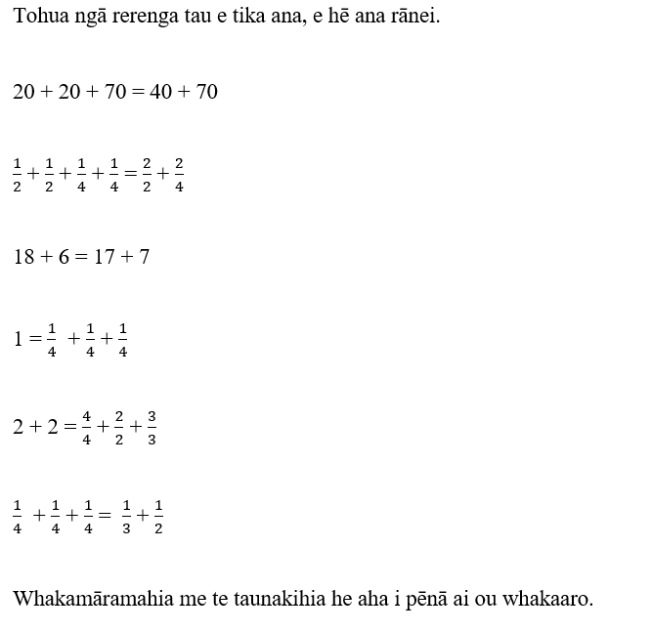

**Rapanga 3**

He aha kei waenganui i te 0 me te 1?

Tohua ngā tau i te papa mā te tēpa whakapiri. Me whakamārama, ā, me taunakihia.

Tāngia i tau rarangi tau me te tohu ngā nama.

Whakaatuhia e whā ngā nama i waenga i te 1-2. Tohua ēnei nama.

**Ngohe 3**

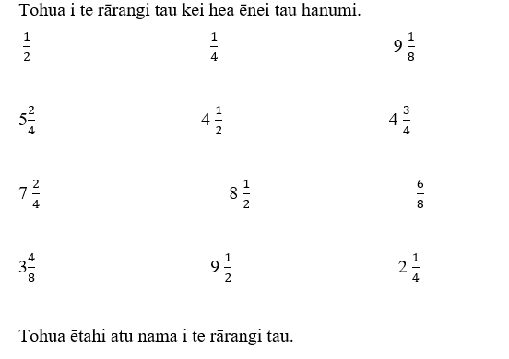

**Rapanga 4**

Kei te hoko tētahi toa kēkē i ngā kēkē panana. He orite ngā kēkē katoa.

Tokotoru ngā tamariki i te whānau o Jamie e toha ana i tētahi kēkē.

Tokoono ngā tamariki i te whānau o Tarani e toha ana i tētahi kēkē.

Tokowaru ngā tamariki i te whānau o Mere e toha ana i tētahi kēkē.

Tokorua ngā tamariki i te whānau o Hoani e toha ana i tētahi kēkē.

Tokowhā ngā tamariki i te whānau o Timo e toha ana i tētahi kēkē.

Kei a wai te maha o te kēkē? Taunakihia me te whakamārama ou whakautu mā ngā tauira e toru.

**Ngohe 4**

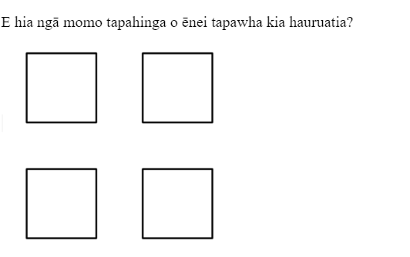

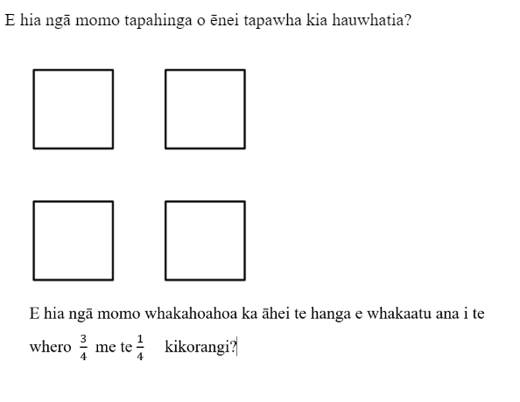

**Rapanga 5**

E toha orite ana a Tama rātou ko Lelei, ko Lily e rima ngā keke pua’a. He orite te āhua o ngā keke pua’a.   
E hia ngā kēkē ka whiwhi ia tangata?

E toha orite ana a Tama rātou ko Lelei, ko Lily e whitu ngā keke pua’a. He orite te āhua o ngā keke pua’a.   
E hia ngā kēkē ka whiwhi ia tangata?

E toha orite ana a Tama rātou ko Lelei, ko Lily e whā ngā keke pua’a. He orite te āhua o ngā keke pua’a.   
E hia ngā kēkē ka whiwhi ia tangata?

**Ngohe 5**

E toha orite ana a Tama rātou ko Lelei, ko Lily e rima ngā keke pua’a. He orite te āhua o ngā keke pua’a.   
E hia ngā kēkē ka whiwhi ia tangata?

E toha orite ana a Tama rātou ko Lelei, ko Lily e whitu ngā keke pua’a. He orite te āhua o ngā keke pua’a.   
E hia ngā kēkē ka whiwhi ia tangata?

E toha orite ana a Tama rātou ko Lelei, ko Lily e iwa ngā keke pua’a. He orite te āhua o ngā keke pua’a.   
E hia ngā kēkē ka whiwhi ia tangata?

**Rapanga 6**

Kei te tunu panikeke te Māmā o Mireka. Ka whakaaro a Mireka ko wai ngā tamaiti ka whiwhi te nuinga o ngā panikeke.

Tokorua ngā tamaiti e toha ana e 3 ngā panikeke.

Tokoiwa ngā tamaiti e toha ana e 9 ngā panikeke.

Me whakaatu ou whakamārama i ngā ara rerekē.

**Ngohe 6**

I tunu pārāoa tētahi Pāpā. Pehea te nui o tau pāraoa mēnā ka toha:

10 ngā kotinga ki ngā tangata e 6.

12 ngā kotinga ki ngā tangata e 8.

E 6 ngā kotinga ki ngā tangata e 4.

E 7 ngā kotinga ki ngā tangata e 5.

Tā me te tuhi au whakautu.

**Rapanga 7**

E hiahia ana a Miri ki te toha tana tiakereti ki āna hoa e 5.

Kei ia hoa he hauwha o te tiakereti.

E hia ngā tiakereti a Miri?

E hiahia ana a Miri ki te toha tana tiakereti ki āna hoa e 8.

Kei ia hoa he hautoru o te tiakereti.

E hia ngā tiakereti a Miri?

**Ngohe 7**

E hiahia ana a Miri ki te toha tana tiakereti ki āna hoa 10.

Kei ia hoa he haurua o te tiakereti.

E hia ngā tiakereti a Miri?

E hiahia ana a Miri ki te toha tana tiakereti ki āna hoa e 5.

Kei ia hoa he hauwha o te tiakereti.

E hia ngā tiakereti a Miri?

E hiahia ana a Miri ki te toha tana tiakereti ki āna hoa e 8.

Kei ia hoa he hauono o te tiakereti.

E hia ngā tiakereti a Miri?

**Rapanga 8**

Ka rākei koe tō kēkē huritau ki ngā rare tiakereti M&M 20. Ka tapahi te kēkē kia hauwha ngā wāhanga me te toha ngā rare tiakereti M&M.

E hia ngā M&M ki ia wāhanga?

Ka rākei koe tō kēkē huritau ki ngā rare tiakereti M&M 18. Ka tapahi te kēkē kia toru ngā wāhanga me te toha ngā rare tiakereti M&M.

He aha te hautanga o ngā rare M&M?

E hia ngā M&M ki ia wāhanga?

Ka rākei koe tō kēkē huritau ki ngā rare tiakereti M&M 40. Ka tapahi te kēkē kia 5 ngā wāhanga me te toha ngā rare tiakereti M&M.

He aha te hautanga o ngā rare M&M?

E hia ngā M&M ki ia wāhanga?

**Ngohe 8**

12 ngā rare tāu. Ka toha koe ki tō hoa.

He aha te hautanga?

E hia ngā rare ka whiwhi kōrua?

24 ngā rare tāu. Ka toha koe ki ngā hoa e 3.

He aha te hautanga?

E hia ngā rare ka whiwhi koutou?

He aha te hauwha o te 8?

He aha te hauwha o te 80?

He aha te haurua o te 10?

He aha te haurua o te 100?

He aha te hautoru o te 6?

He aha te hautoru o te 60?

**Rapanga 9**

Kei te tākaro tahi a Tino me āna hoa e 3 i ngā anga pipi. I kohi 28 ngā anga pipi.Ka toha ngā anga pipi katoa. E hia ngā anga pipi ka whiwhi ia tamaiti? He aha te hautau ka whiwhi ia tamaiti?

Kei te tākaro tahi a Tino me āna hoa e 5 i ngā anga pipi. I kohi 60 ngā anga pipi.Ka toha ngā anga pipi katoa. E hia ngā anga pipi ka whiwhi ia tamaiti? He aha te hautau ka whiwhi ia tamaiti?

Kei te tākaro tahi a Tino me āna hoa e 7 i ngā anga pipi. I kohi 40 ngā anga pipi.Ka toha ngā anga pipi katoa. E hia ngā anga pipi ka whiwhi ia tamaiti? He aha te hautau ka whiwhi ia tamaiti?

**Ngohe 9**

He aha te hauwha o te 4?

He aha te hauwha o te 40?

He aha te hauwha o te 400?

He aha te haurua o te 20?

He aha te haurua o te 200?

He aha te haurua o te 220?

He aha te hautoru o te 9?

He aha te hautoru o te 90?

He aha te hautoru o te 990?

He aha te hauwha o te 8?

He aha te hauwha o te 40?

He aha te hauwha o te 48?

He aha te hauono o te 6?

He aha te hauono o te 30?

He aha te hauono o te 36?

He aha te hautoru o te 9?

He aha te hautoru o te 30?

He aha te hautoru o te 39?

**Rapanga 10**

Ka hanga a Tiare i tētahi mea roroha (elastic). 3 ngā mita kia hanga tana mea roroha, engari ka hoatu tana Māmā i ētahi mea paku noa.

Tuatahi ka hoatu tana Māmā he 1 me te 1/2 mita. Engai ka kohi e 3 ngā mea 1/2 mita te roanga.

Pehea te roanga o āna roroha katoa?

He maha te roroha ki te hanga tana mea tākaro roroha?

Ka hanga a Tiare i tētahi mea roroha (elastic). 3 ngā mita kia hanga tana mea roroha, engari ka hoatu tana Māmā i ētahi mea paku noa.

Tuatahi ka hoatu tana Māmā he 2 1/4 mita. Engai ka kohi e 3 ngā mea 1/4 mita te roanga.

Pehea te roanga o āna roroha katoa?

He maha te roroha ki te hanga tana mea tākaro roroha?

**Ngohe 10**

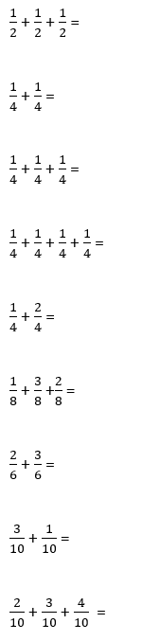

**Rapanga 11**

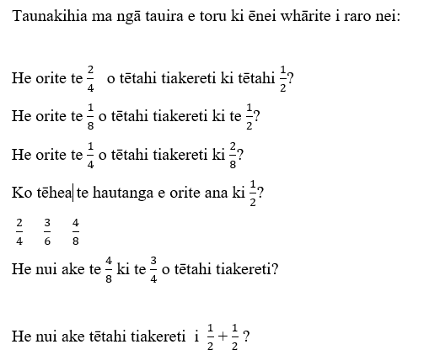

**Ngohe 11**

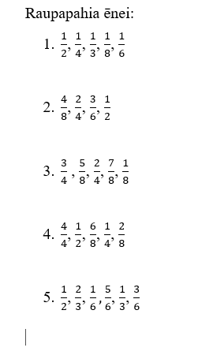

**Rapanga 12**

