| HANGAIA  TE URUPOUNAMU MŌ TĀTOU  **HAUTANGA** Taumata 2 (Tau 4) Copy Masters ODD YEARS |
| --- |

**©** Developing Mathematical Inquiry Communities team, Institute of Education, Massey University

**Rapanga 1**

Whakamahia te rauemi hautanga kia hanga te kōtahi ki ngā taputapu hautanga rerekē. Tuhia me te tā to whakaturanga. Me whakamārama me te taunakihia ngā take ka hanga ngā wāhanga ki te kōtahi.

Whakamahia te rauemi hautanga kia hanga tata ki te kōtahi ki ngā taputapu hautanga rerekē. Tuhia me te tā to whakaturanga. Me whakamārama me te taunakihia ngā take ka hanga ngā wāhanga e tata ana ki te kōtahi.

Whakamahia te rauemi hautanga kia hanga nui ake i te kōtahi ki ngā taputapu hautanga rerekē. Tuhia me te tā to whakaturanga. Me whakamārama me te taunakihia ngā take ka hanga ngā wāhanga nui ake i te kōtahi.

**Ngohe 1**

E hia ngā momo tapahinga o ēnei tapawhā kia haurutia?

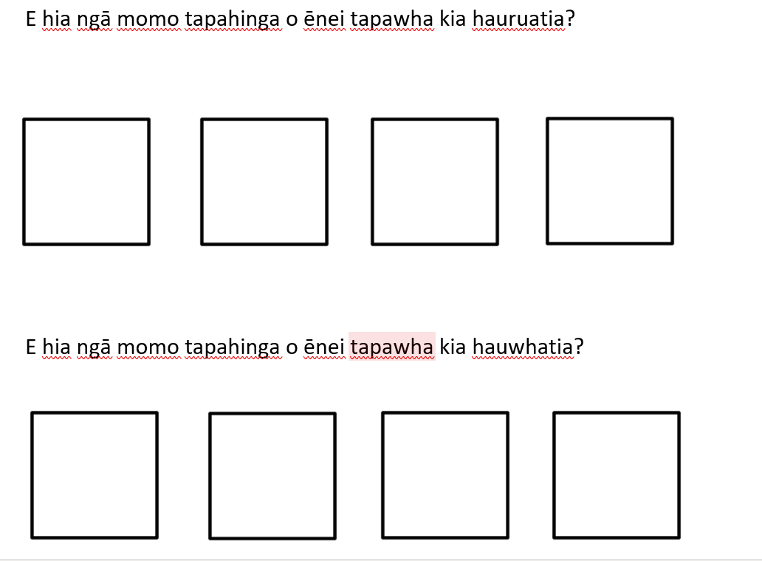



E hia ngā momo tapahinga o ēnei tapawhā ki hauwhatia?





**Rapanga 2**

Whakamahia te rauemi hautanga kia hanga he hautanga i raro i te haurua mā ngā taputapu hautanga rerekē. Tuhia me te tā to whakaaturanga. Me whakamārama me te taunakihia ngā take ka hanga ngā hautau nui ake ite haurua engari he iti iho i te kōtahi.

Whakamahia te rauemi hautanga kia hanga he mea nui ake i te haurua engari he iti iho i te kōtahi mā ngā taputapu hautanga rerekē. Tuhia me te tā to whakaaturanga. Me whakamārama me te taunakihia ngā take ka hanga ngā hautau nui ake ite haurua engari he iti iho i te kōtahi.

Whakamahia te rauemi hautanga kia hanga nui ake ite kōtahi engari he iti iho i te rua mā ngā taputapu hautanga rerekē. Tuhia me te tā tō whakaaturanga. Me whakamārama me te taunakihia ngā take ka hanga ngā wāhanga ki te kōtahi iti iho.

**Ngohe 2**

Whakamahia te rauemi hautau kia hanga ētahi huinga hautau ki te kōtahi. Tā me te tuhi kia toru ngā momo tauira.

Whakamahia te rauemi hautau kia hanga ētahi huinga hautau e tata ana ki te kōtahi. Tā me te tuhi kia toru ngā momo tauira.

Whakamahia te rauemi hautau kia hanga ētahi huinga hautau nui ake i te kōtahi. Tā me te tuhi kia toru ngā momo tauira.

**Rapanga 3**

He aha kei waenganui i te 0 me te 1?

Tohua ngā tau i te papa mā te tēpa whakapiri. Me whakamārama, ā, me taunakihia.

Tāngia i tau rarangi tau me te tohu ngā nama.

Whakaatuhia e whā ngā nama i waenga i te 1-2. Tohua ēnei nama.

**Ngohe 3**

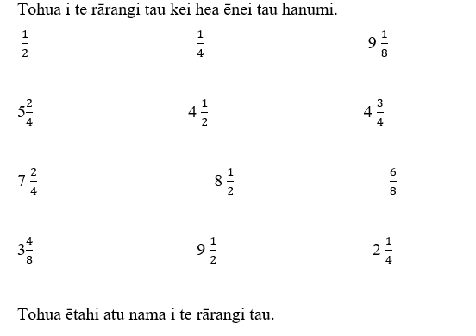

**Rapanga 4**

I tētahi mākete e āhei ana koe ki te hoko tētahi pouaka poke panana he tapawhāroa te āhua o te pouaka. He orite te āhua o ngā pouaka katoa.

Tokotoru ngā tamariki i te whānau o Nooroa e toha ana i tētahi pouaka poke panana.

Tokowaru ngā tamariki ei te whānau o Hone e toha ana i tētahi pouaka poke panana.

Tokoono ngā tamariki i te whānau o Rangi e toha ana i tētahi pouaka poke panana.

Tokowhā ngā tamariki i te whānau o Matene e toha ana i tētahi pouaka poke panana.

Tokorima ngā tamariki i te whānau o Pihama e toha ana i tētahi pouaka poke panana.

Kei a wai te maha o te poke panana? Taunakihia me te whakamārama ou whakautu mā ngā tauira e toru pēnei i te rarangi tau, i te pikitia, i te tauira hautanga hoki.

**Ngohe 4**

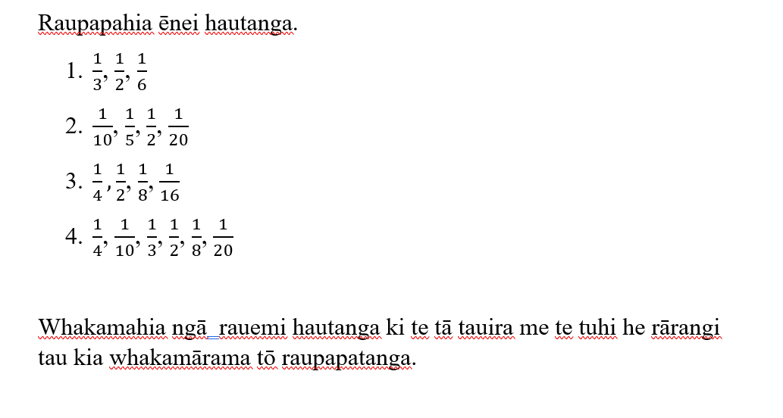

**Rapanga 5**

Kei te tunu panikeke te Māmā o Mireka. Ka whakaaro a Mireka ko wai ngā tamaiti ka whiwhi te nuinga o ngā panikeke.

Tokowaru ngā tamaiti e toha ana 10 ngā panikeke.

Tokorua ngā tamaiti e toha ana e 3 ngā panikeke.

Tokowhā ngā tamaiti e toha ana e 9 ngā panikeke.

Tokorima ngā tamaiti e toha ana e 4 ngā panikeke.

Me whakaatu ou whakamārama i ngā ara rerekē.

**Ngohe 5**

Ānei ngā tapeke i tētahi whakataetae poiwhana.

I whana a Ruby e 5 o te 6 o ngā piro.

I whana a Rawiri e 2 o te 3 o ngā piro.

I whana a Tonga e 3 o te 4 o ngā piro.

I whana a Rawinia e 7 o te 8 o ngā piro.

Rauapapahia ēnei mai te mea nui ake ki te mea iti iho.

**Rapanga 6**

Kei te toha a Mahina i tana rare ki āna hoa e 5.

He hauwha kei a Mahina me āna hoa. E hia ngā rare ā Mahina ki te toha?

Kei te toha a Mahina i tana rare ki āna hoa e 8.

He hautoru kei a Mahina me āna hoa. E hia ngā rare ā Mahina ki te toha?

Kei te toha a Mahina i tana rare ki āna hoa e 9.

E rua haurima kei a Mahina me āna hoa. E hia ngā rare ā Mahina ki te toha?

**Ngohe 6**

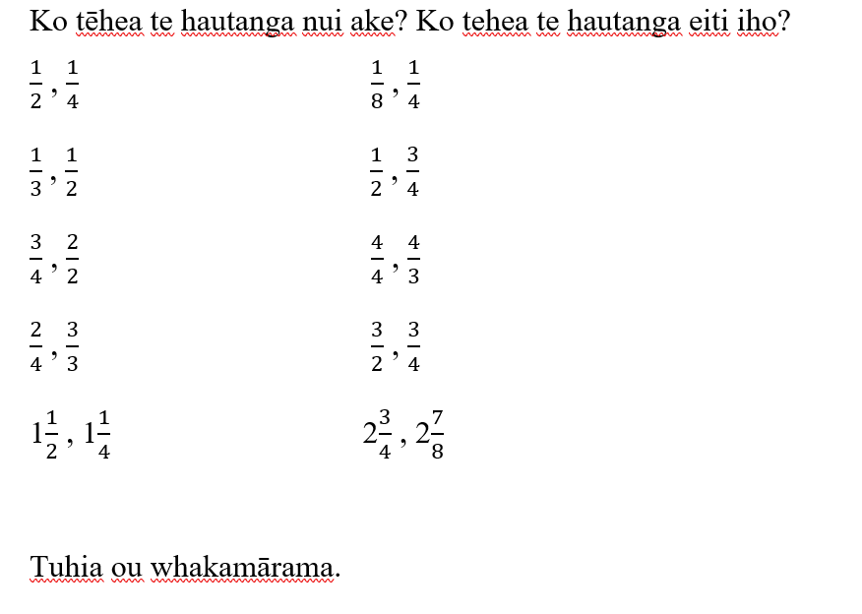

**Rapanga 7**

Kei au e rua ngā kotinga poaka tote (ham).He hauwhā o tētahi kotinga poaka tote ki te hanga he hanuwiti. E hia ngā hanuwiti e āhei ana ki te hanga?

Kei au e toru ngā kotinga poaka tote (ham).He hautoru o tētahi kotinga poaka tote ki te hanga he hanuwiti. E hia ngā hanuwiti e āhei ana ki te hanga?

Kei au e rima ngā kotinga poaka tote (ham). E rua hautoru o ngā kotinga poaka tote ki te hanga he hanuwiti. E hia ngā hanuwiti e āhei ana ki te hanga?

**Ngohe 7**

E hia ngā haurua i:

· Tētahi kotinga poaka tote

· E rua ngā kotinga poaka tote

· Tekau ngā kotinga poaka tote

E hia ngā hauwhā i:

· Tētahi kotinga poaka tote

· E rua ngā kotinga poaka tote

· E toru ngā kotinga poaka tote

· Tekau ngā kotinga poaka tote

E hia ngā hautoru i:

· Tētahi kotinga poaka tote

· E rua ngā kotinga poaka tote

· E toru ngā kotinga poaka tote

· Tekau ngā kotinga poaka tote

He aha te tauira e kite ana koe?

Na, tuhia tau ake rerenga tau e whakaatu ana i nga hautau me ngā kotinga poaka tote.

**Rapanga 8**

I awhi a Ayla rāua ko Jack i ā rāua Māmā ki te peita i te whare. He peita tini karaka tā rāua.

I mahia he haurua o te tini o Jack.

I mahia e toru hauwha o te tini o Ayla.

He aha te toenga o ngā tini peita karaka e rua?

I awhi a Ayla rāua ko Jack i ā rāua Māmā ki te peita i te whare. He peita tini karaka tā rāua.

I mahia e toru hauwaru o te tini o Jack.

I mahia e toru hauwha o te tini o Ayla.

He aha te toenga o ngā tini peita karaka e rua?

I awhi a Ayla rāua ko Jack i ā rāua Māmā ki te peita i te whare. He peita tini karaka tā rāua.

I mahia he haurua o te tini o Jack.

I mahia e toru haurima o te tini o Ayla.

He aha te toenga o ngā tini peita karaka e rua?

**Ngohe 8**

I awhi a Ayla rāua ko Jack i ā rāua Māmā ki te peita i te whare. He peita tini karaka tā rāua.

I mahia he haurua o te tini o Jack.

I mahia he hauwhā o te tini o Ayla.

He aha te toenga o ngā tini peita karaka e rua?

I awhi a Ayla rāua ko Jack i ā rāua Māmā ki te peita i te whare. He peita tini karaka tā rāua.

I mahia he hauwhā o te tini o Jack.

I mahia he hauwaru o te tini o Ayla.

He aha te toenga o ngā tini peita karaka e rua?

I awhi a Ayla rāua ko Jack i ā rāua Māmā ki te peita i te whare. He peita tini karaka tā rāua.

I mahia he haurua o te tini o Jack.

I mahia e toru hautoru o te tini o Ayla.

He aha te toenga o ngā tini peita karaka e rua?

I awhi a Ayla rāua ko Jack i ā rāua Māmā ki te peita i te whare. He peita tini karaka tā rāua.

I mahia he hauono o te tini o Jack.

I mahia e rua hautoru o te tini o Ayla.

He aha te toenga o ngā tini peita karaka e rua?

**Rapanga 9**

Ka rākei koe tō kēkē huritau ki ngā rare tiakereti M&M 20. Ka tapahi te kēkē kia hauwha ngā wāhanga me te toha ngā rare tiakereti M&M.

E hia ngā M&M ki ia wāhanga?

Ka rākei koe tō kēkē huritau ki ngā rare tiakereti M&M 18. Ka tapahi te kēkē kia hautoru ngā wāhanga me te toha ngā rare tiakereti M&M.

E hia ngā M&M ki ia wāhanga?

Ka rākei koe tō kēkē huritau ki ngā rare tiakereti M&M 40. Ka tapahi te kēkē kia haurima ngā wāhanga me te toha ngā rare tiakereti M&M.

E hia ngā M&M ki ia wāhanga?

**Ngohe 9**

12 ngā rare tāu. Ka toha koe ki tō hoa.

He aha te hautanga?

E hia ngā rare ka whiwhi kōrua?

24 ngā rare tāu. Ka toha koe ki ngā hoa e 3.

He aha te hautanga?

E hia ngā rare ka whiwhi koutou?

He aha te hauwha o te 8?

He aha te hauwha o te 80?

He aha te haurua o te 10?

He aha te haurua o te 100?

He aha te hautoru o te 6?

He aha te hautoru o te 60?

**Rapanga 10**

Kei te hanga a Leilani i tētahi tauira mā ngā piere. 16 ngā piere whero, 40 ngā piere kahurangi, 24 ngā piere kowhai.

Ka whakawehe te tauira kia hauwhā engari he orite te nama o ngā piere.

E hia ngā piere o ia kara ka whakamahia e ia?

Mēnā ka whakawehe te tauira kia hauwaru e hia ngā piere o ia kara?

**Ngohe 10**

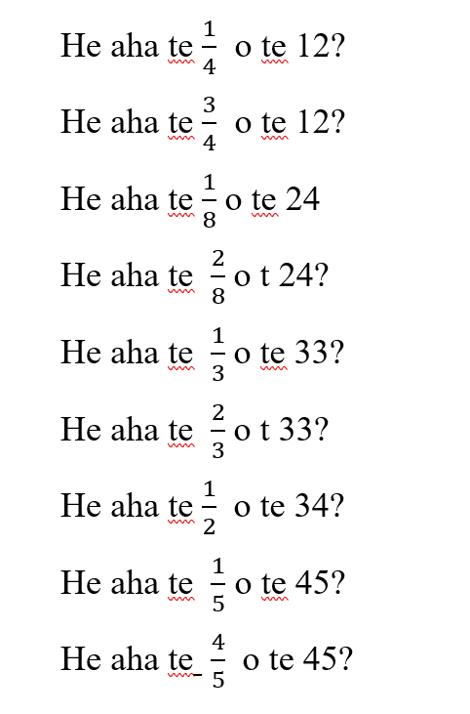

**Rapanga 11**

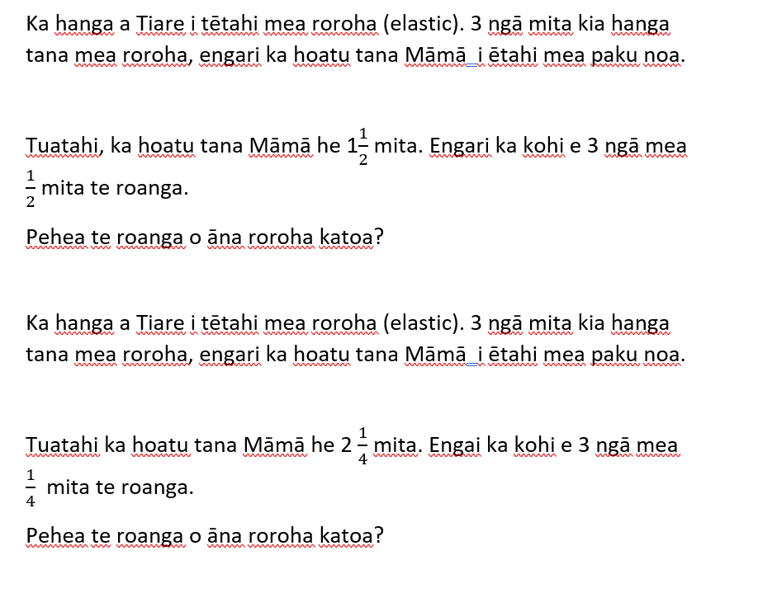

**Ngohe 11**

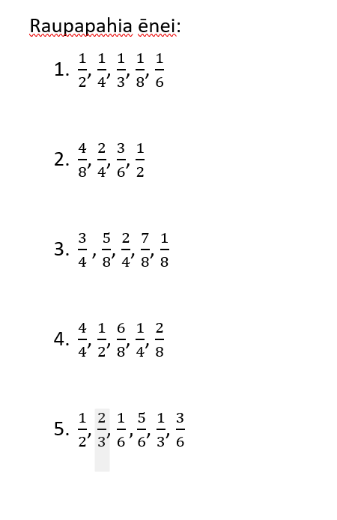

**Rapanga 12**

E 2 ngā pātara wai reka ā Hone me āna tungane a Wiremu rāu ko Jo. Ka inu ¾ o tētahi pātara.

I inu a Wiremu 5/8 o tētahi pātara.

Ka inu a Jo i te toenga.

He aha te hautau o te inu inu a Jo?

E 2 ngā pātara wai reka ā Hone me āna tungane a Wiremu rāu ko Jo. Ka inu 3/6 o tētahi pātara.

I inu a Wiremu 2/3 o tētahi pātara.

Ka inu a Jo i te toenga.

He aha te hautau o te inu inu a Jo?

E 2 ngā pātara wai reka ā Hone me āna tungane a Wiremu rāu ko Jo. Ka inu 1/5 o tētahi pātara.

I inu a Wiremu 4/5 o tētahi pātara.

Ka inu a Jo i te toenga.

He aha te hautau o te inu inu a Jo?