| HANGAIA  TE URUPOUNAMU MŌ TĀTOU  **HAUTANGA** Taumata 3 (Tau 5-6) Copy Masters ODD YEARS |
| --- |

**©** Developing Mathematical Inquiry Communities team, Institute of Education, Massey University

**Rapanga 1**

Whakamahia te rauemi hautanga kia hanga te kōtahi ki ngā taputapu hautanga rerekē. Tuhia me te tā to whakaturanga. Me whakamārama me te taunakihia ngā take ka hanga ngā wāhanga ki te kōtahi.

Whakamahia te rauemi hautanga kia hanga ngā hautanga he iti iho i te haurua engari he nui ake i te rua hautekau mā rua taputapu hautanga rerekē. Tuhia me te tā to whakaturanga. Me whakamārama me te taunakihia ngā take ka hanga ngā wāhanga e tata ana ki te kōtahi.

Whakamahia te rauemi hautanga kia hanga ngā hautanga nui ake I te kōtahi engari he iti iho I te 1 me te 1/2 ki ngā taputapu hautanga rerekē. Tuhia me te tā to whakaturanga. Me whakamārama me te taunakihia ngā take ka hanga hautanga pēnā.

**Ngohe 1**

He aha ētahi atu hautanga e orite ana ki te 1?

Tuhi me te tā ou whakamārama.

He aha ētahi hautau e orite ana ki te hauwha?

Tuhi me te tā ou whakamārama

He aha ētahi hautau e orite ana ki te hautoru?

Tuhi me te tā ou whakamārama mā te pikitia me te whārite.

He aha ētahi hautau e orite ana ki te haurima?

Tuhi me te tā ou whakamārama mā te pikitia me te whārite.

He aha ētahi hautau e orite ana ki te hauwaru?

Tuhi me te tā ou whakamārama mā te pikitia me te whārite.

**Rapanga 2**

Whakamahia te rauemi hautanga kia hanga ngā hautanga he iti iho I te ½ engari he nui ake i te ¼ ki ngā taputapu hautanga rerekē. Tuhia me te tā to whakaturanga. Me whakamārama me te taunakihia ngā take ka hanga hautanga pēnā.

Whakamahia te rauemi hautanga kia hanga ngā hautanga i waenga I te 2/3 me te 7/8 ki ngā taputapu hautanga rerekē. Tuhia me te tā to whakaturanga. Me whakamārama me te taunakihia ngā take ka hanga hautanga pēnā.

Whakamahia te rauemi hautanga kia hanga ngā hautanga nui ake i te 1 engari he iti iho I te 1 1/3 ki ngā taputapu hautanga rerekē. Tuhia me te tā to whakaturanga. Me whakamārama me te taunakihia ngā take ka hanga hautanga pēnā.

Whakamahia te rauemi hautanga kia hanga ngā hautanga e orite ana ki 1/5 ki ngā taputapu hautanga rerekē. Tuhia me te tā to whakaturanga. Me whakamārama me te taunakihia ngā take ka hanga hautanga pēnā.

Whakamahia te rauemi hautanga kia hanga ngā hautanga e orite ana ki 1/8 ki ngā taputapu hautanga rerekē. Tuhia me te tā to whakaturanga. Me whakamārama me te taunakihia ngā take ka hanga hautanga pēnā.

**Ngohe 2**

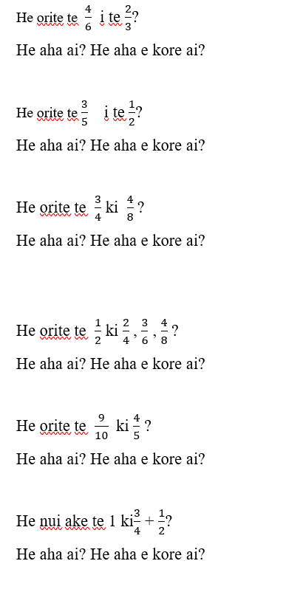

**Rapanga 3**

Kei te tākaro a Tiana me āna hoa i tētahi kēmu. Ko te ture matua, me whakaae, kare i whakaae rānei i ngā kōrero i raro nei:

E ai ki a Tiana 15 ngā nama i waenga i te 1 me te 2. Kare i whakaae mai āna hoa, engari ka hē rātou.

Ka taea e koe te hāponohia i nga 15 o ngā nama i waenga i te 1 me te 2?

Whakamahia he rārangi tau kia whakaatu kei hea ngā nama.

**Ngohe 3**

Tuhia tāu ake reretauāki hautau.

Nā, me hāponohia ia reretauāki kia tika, kia hē rānei. Whakamahia kia rua ngā momo tauira.

**Rapanga 4**

Ko wai i kai te nuinga o ngā keke? Ko wai kāre i kai te nuinga o ngā keke?

A. E 9 ngā tamariki e toha ana i ngā keke 10.

B. E 5 ngā tamariki e toha ana i ngā keke e 3.

C. E 3 ngā tamariki e toha ana i nga keke e 5.

D. E 4 ngā tamariki e toha ana i ngā keke e 7.

E. E 8 ngā tamariki e toha ana i ngā keke12.

F. 12 ngā tamariki e toha ana i ngā keke18.

Raupapahia ēnei.

Me whakamārama, me taunakihia ou whakaaro i ngā tauira rerekē.

**Ngohe 4**

Kei te wānanga te tīma Poitarawhiti o Mereana kia whakarite ko wai te kaikōkiri uhunga, ā, ko wai te kaikuru uhunga. I tirohia rātou ki ngā tapeke.

10/12 ngā piro a Lisa

¾ ngā piro a Ann

3/6 ngā piro o Nevaeh

2/3 ngā piro a Aumihia

Ki ou whakaaro, ko wai te kaikōkiri uhunga tika me te kaikuru uhunga tika?

**Rapanga 5**

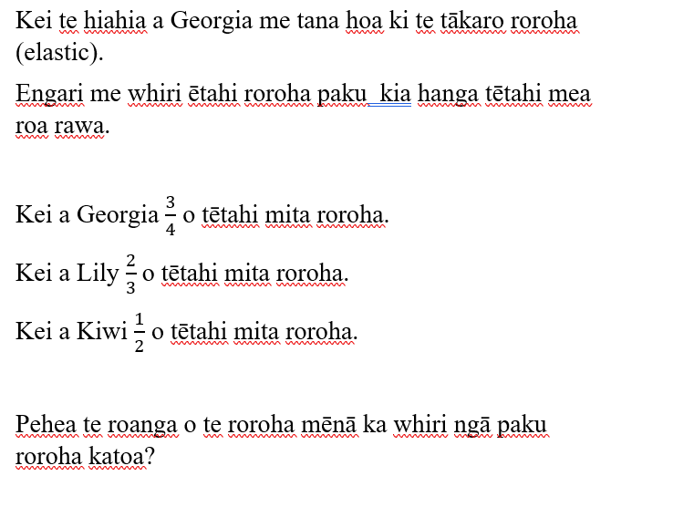

**Ngohe 5**

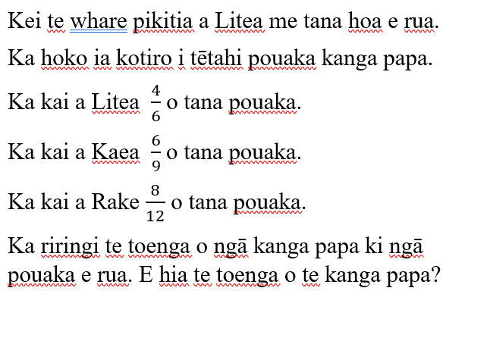

**Rapanga 6**

Kei te hanga a Jean me āna hoa i ētahi mea whakakai mā te one.

E 3 ngā pākete one tā rātou.

I whakamahia a Henare he $\frac{1}{4}$ o tāna pākete one.

I whakamahi a Tane $\frac{2}{3}$ o tana pākete one.

I whakamahia a Rangi $\frac{5}{6}$ o tana pākete one.

I whakamahia a Holly i te toenga.

He aha te hautanga pākete one e toe ana mā Holly?

**Ngohe 6**

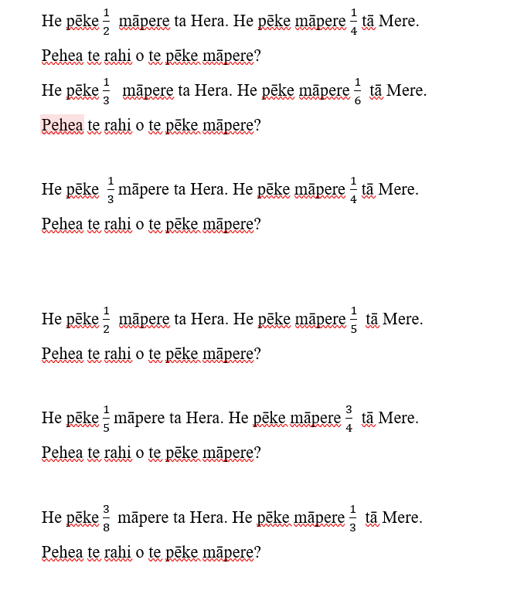

**Rapanga 7**

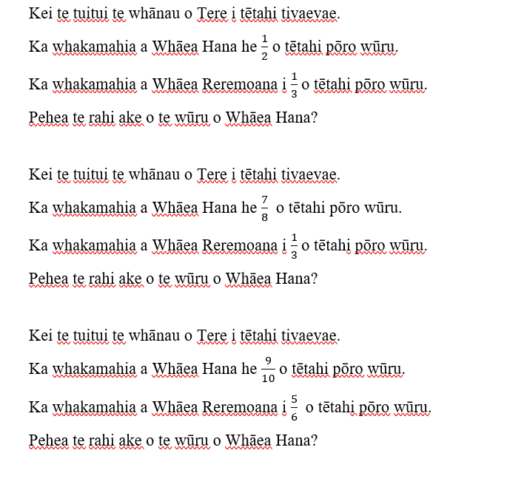

**Ngohe 7**

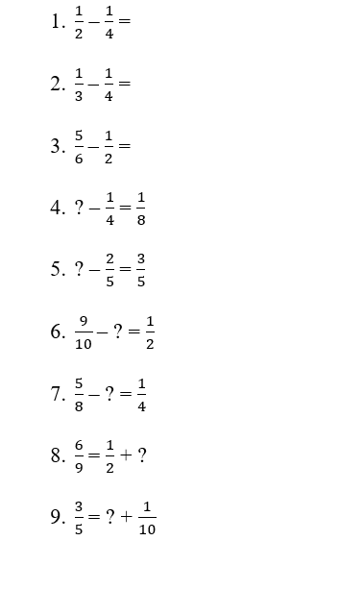

**Rapanga 8**

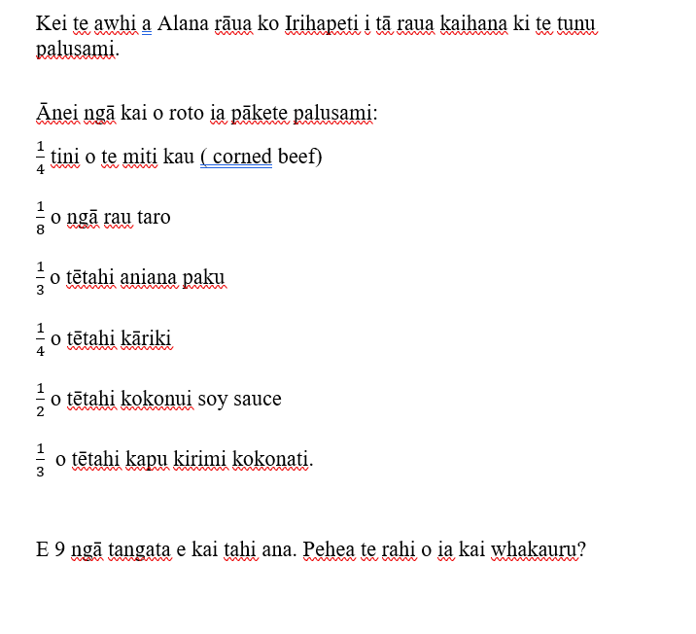

**Ngohe 8**

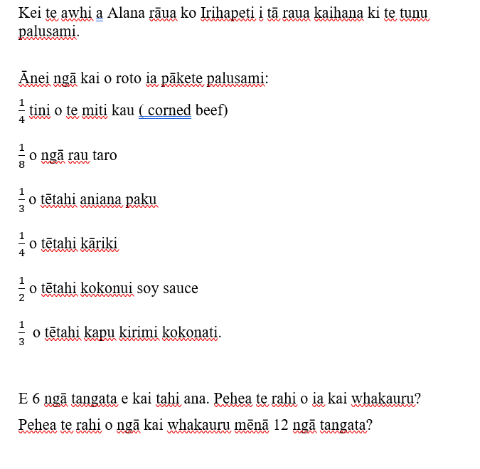

**Rapanga 9**

I kohi a Michaela rāua ko Ava i ngā anga rerekē kia hanga he tauira i te one.

I kohi 60 ngā anga tio, 120 ngā anga pipi, 66 ngā anga kutai hoki.

I te tauira tuatahi, i whakawehe ngā anga i ngā wahanga e 6. E hia ngā momo anga i ia wāhanga? He aha te hautau o ngā anga ki ia wāhanga?

I te tauira tuarua, i whakawehe ngā anga i ngā wahanga e 3. E hia ngā momo anga i ia wāhanga? He aha te hautau o ngā anga ki ia wāhanga?

I te tauira tuatoru, i whakawehe ngā anga i ngā wahanga e 7. E hia ngā momo anga i ia wāhanga? He aha te toenga o ngā anga? He aha te hautanga o ngā anga ki ia wāhanga?

**Ngohe 9**

He pēke māpere 396 tāu. Ka toha koe ki ou hoa e toru.

He aha te hautau?

E hia ngā māpere ki ia hauta?

He pēke māpere 123 tāu. Ka toha koe ki au hoa e toru.

He aha te hautau?

E hia ngā māpere ki ia hautau?

He aha te haurua o te 124?

He aha te haurua o te 1240?

He aha te hauwhā o te 68?

He aha te hauwha o te 680?

He aha te hautoru o te 141?

He aha te hautoru o te 1410?

He aha te haurima o te 50?

He aha te rua haurima o te 50?

He aha te toru haurima o te 50?

**Rapanga 10**

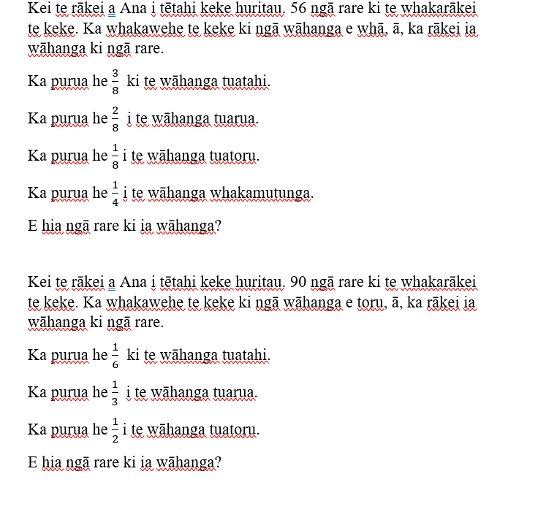

**Ngohe 10**

Whakautu eenei whaarite, aa, ka kite koe i eetahi tauira?

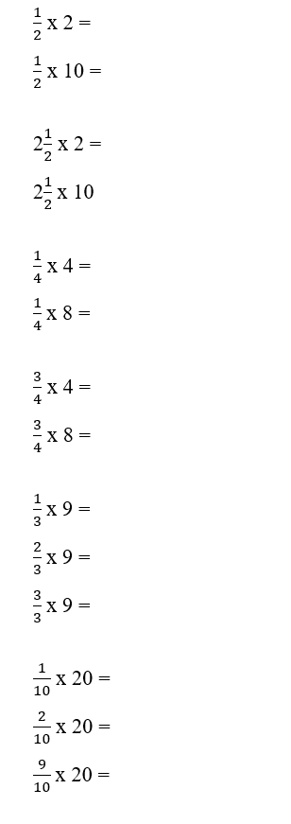

**Rapanga 11**

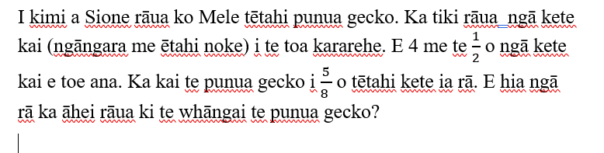

**Ngohe 11**

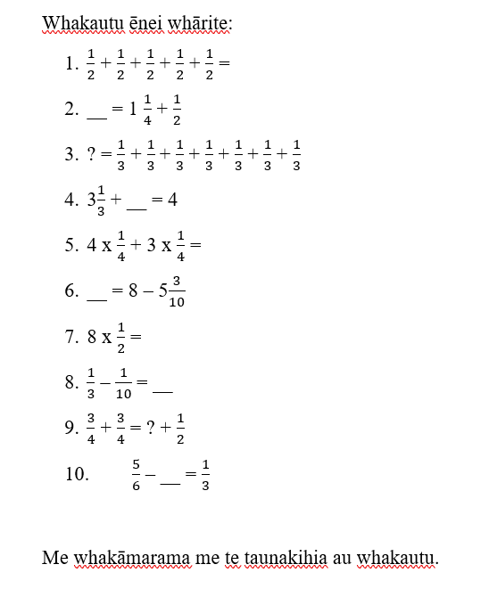

**Rapanga 12**

Whakaoti ēnei whārite:

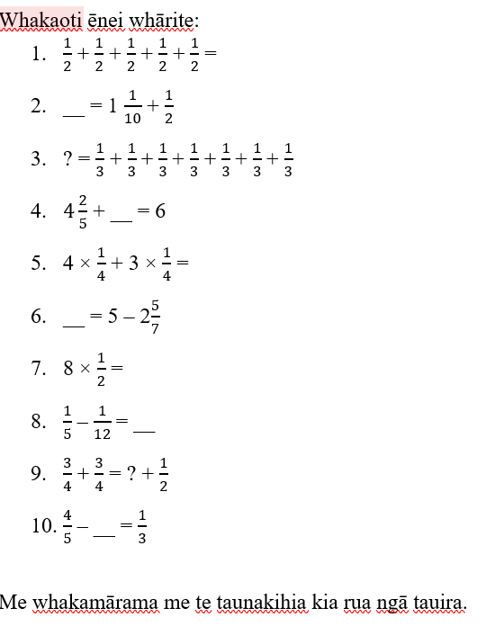

Me whakamārama me te taunakihia kia rua ngā tauira.