|  |
| --- |
| HANGAIA  TE URUPOUNAMU MŌ TĀTOU  **HAUTANGA** Taumata 4 (Tau 7-8) Copy Masters ODD YEARS |

**©** Developing Mathematical Inquiry Communities team, Institute of Education, Massey University

**Rapanga 1**

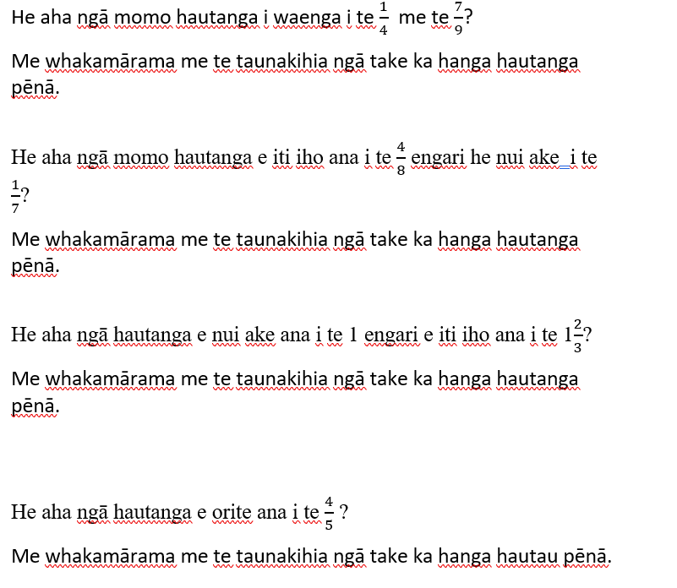

**Ngohe 1**

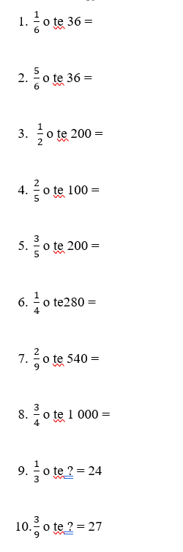

**Rapanga 2**

He nama kei waenganui i ngā nama?

He aha tō whakautu?

Me whakamāramahia tau whakautu.

Me taunakihia au whakautu mā te whakaatu i ēnei:

E 5 ngā nama i mua i te 1.

15 ngā nama i waenga i te 5 me te 6.

Me tuhi he tauira mā te rārangi tau e whakaatu ana au nama.

**Ngohe 2**

Tuhia ētahi pātai hautau e whakamahia ana ou mōhiotanga hautanga.

**Rapanga 3**

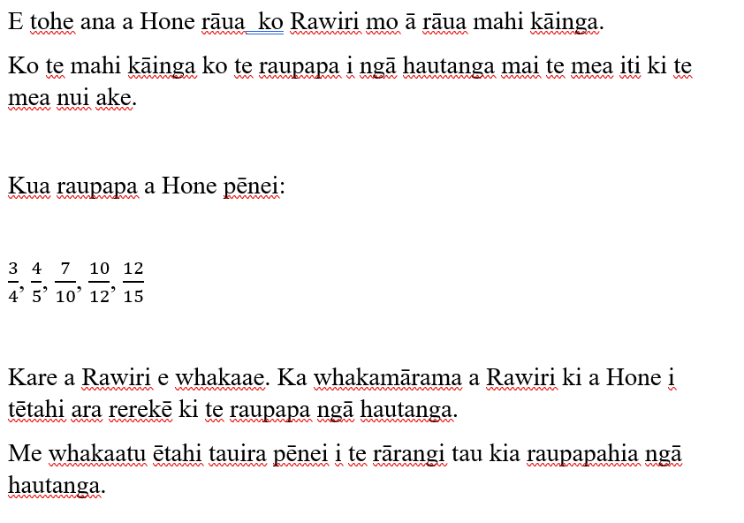

**Ngohe 3**

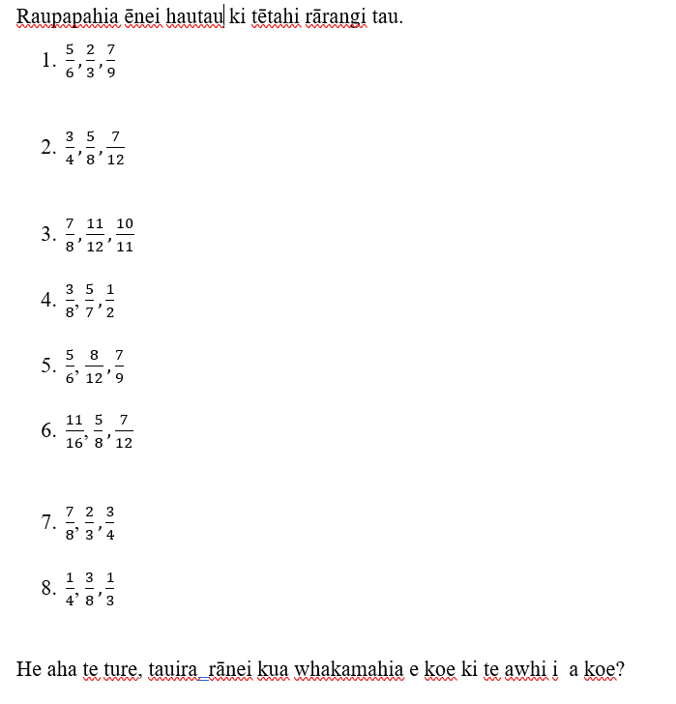

**Rapanga 4**

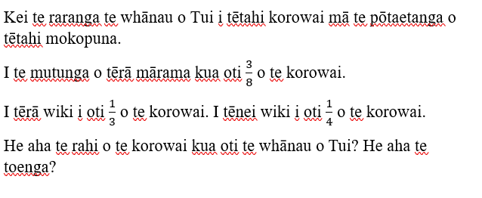

**Ngohe 4**

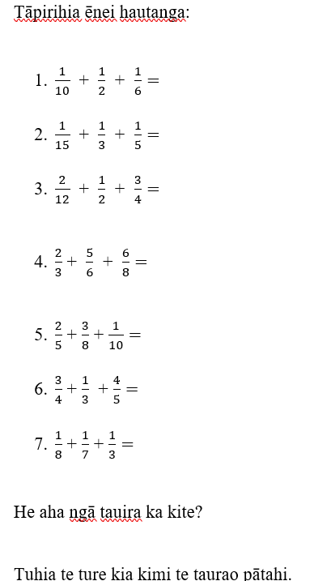

**Rapanga 5**

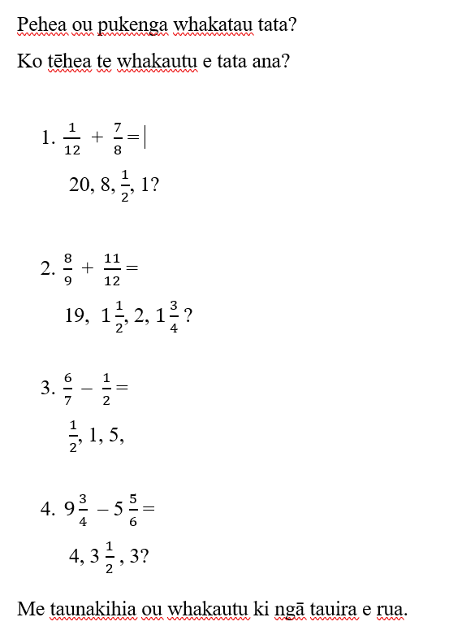

**Ngohe 5**

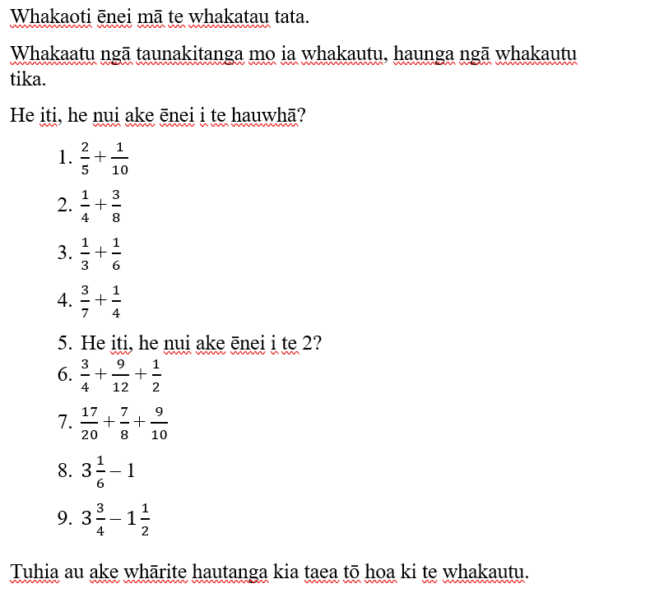

**Rapanga 6**

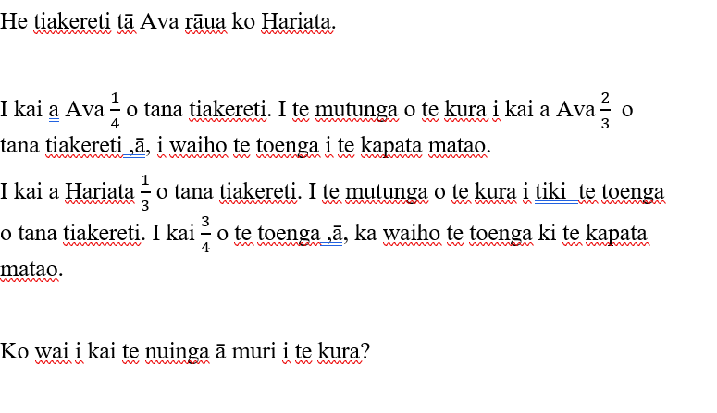

**Ngohe 6**

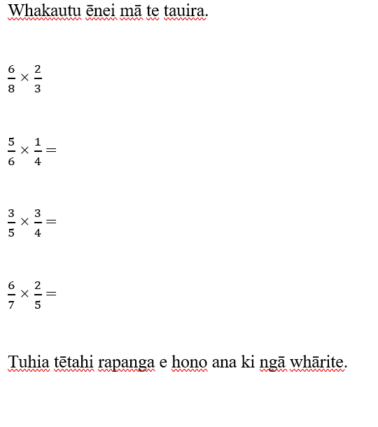

**Rapanga 7**

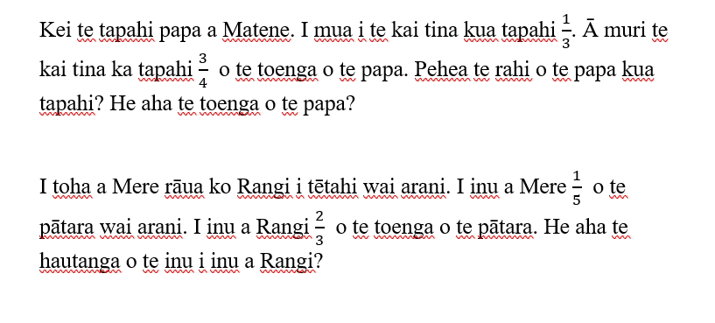

**Ngohe 7**

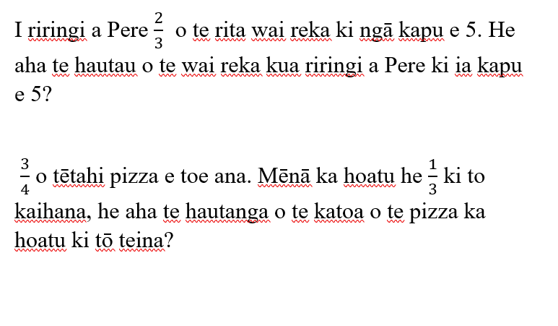

**Rapanga 8**

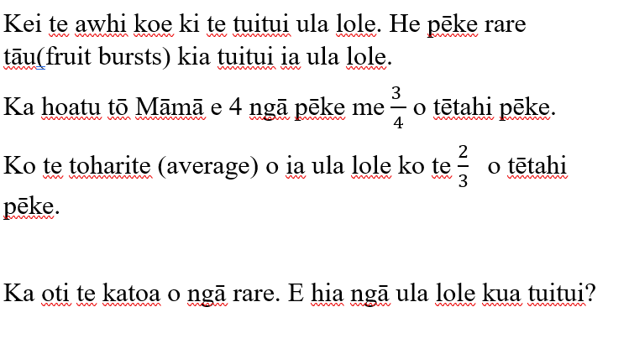

**Ngohe 8**

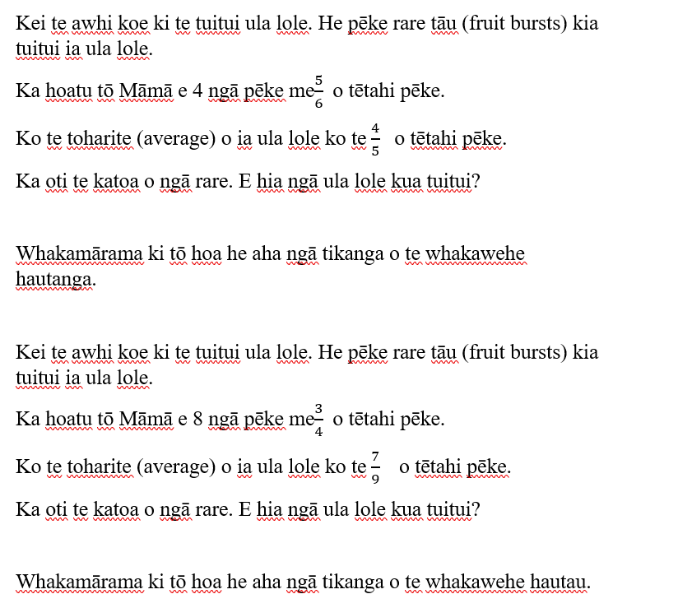

**Rapanga 9**

Kōtahi hāora me te haurima tā Koro ki te whakaoti e toru ngā momo mahi.

Pehea te roanga o ia mahi?

Whakaatu ngā whakautu mā te rārangi tau me ngā porotiti.

Nā, e hia ngā miniti o ia mahi?

**Ngohe 9**

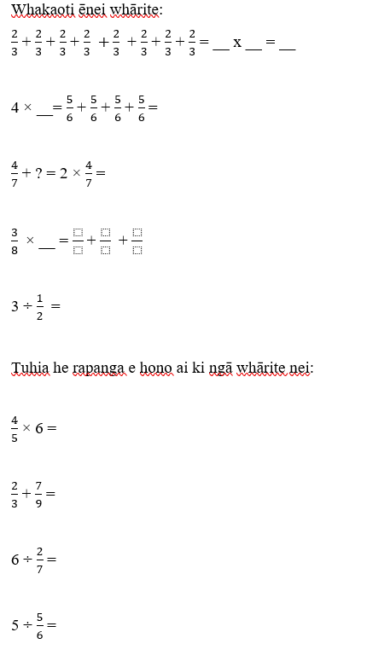

**Rapanga 10**

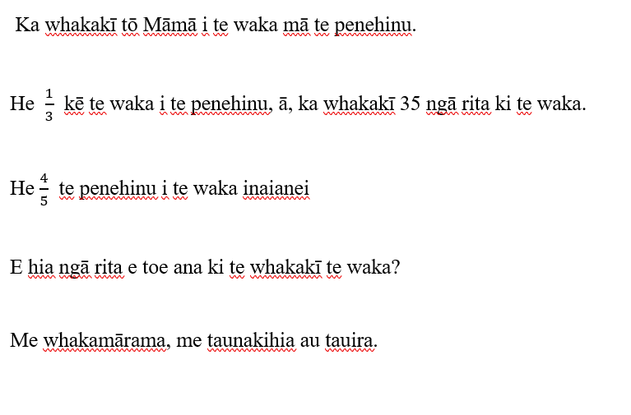

**Ngohe 10**

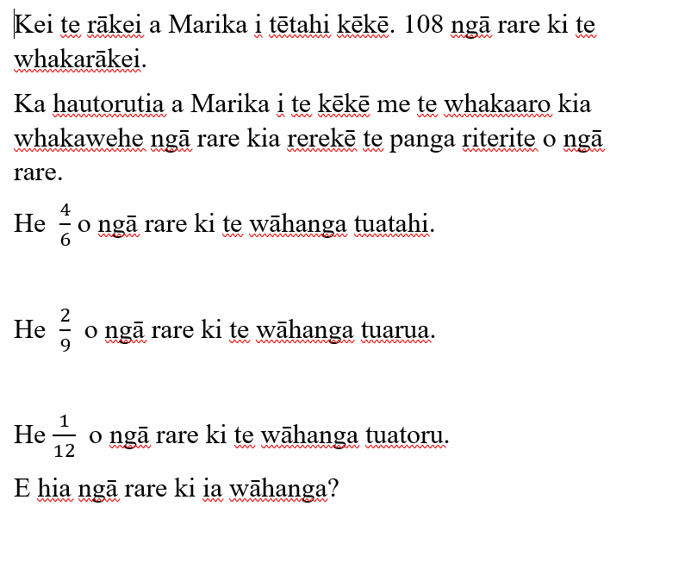

**Rapanga 11**

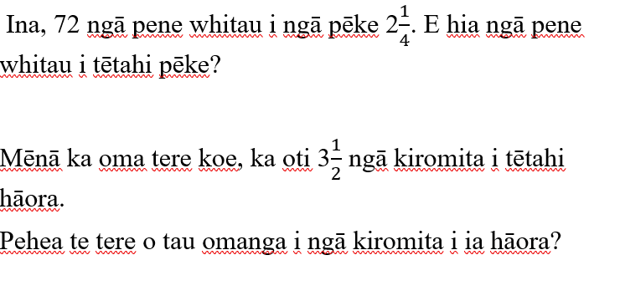

**Ngohe 11**

Ka āhei koe ki te tuhi e 3 ngā whārite hautau whakarea ,ā, me whakautu ngā whārite?

Ka āhei koe ki te tuhi e 3 ngā whārite hautau whakawehe ,ā, me whakautu ngā whārite?

**Rapanga 12**

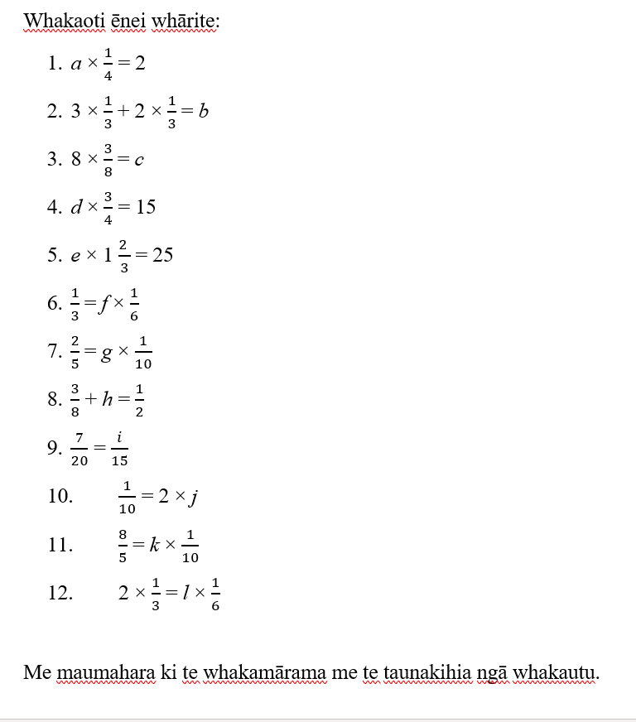

**Ngohe 12**